**Software Engineering Tools Lab**

**Assignment No-5**

(Module 4- Documentation tools)

**PRN: 2019BTECS00017**

**Full name: Muskan Raju Attar**

**Batch: T1**

Q 1. In your respective GitHub repository create a wiki page named ‘SET Lab’. Add description of ‘GitHub wiki’ in that respective page.

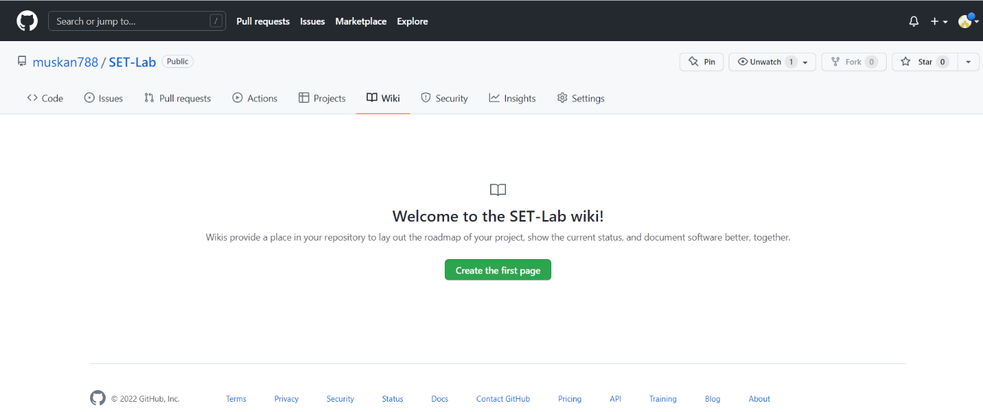

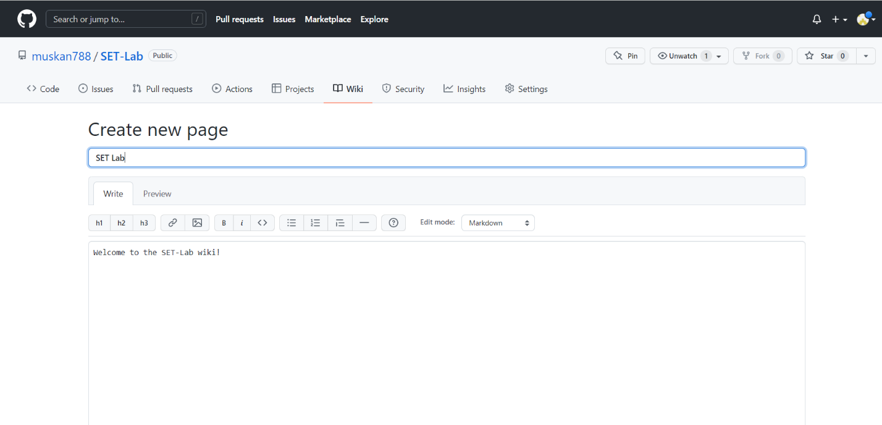

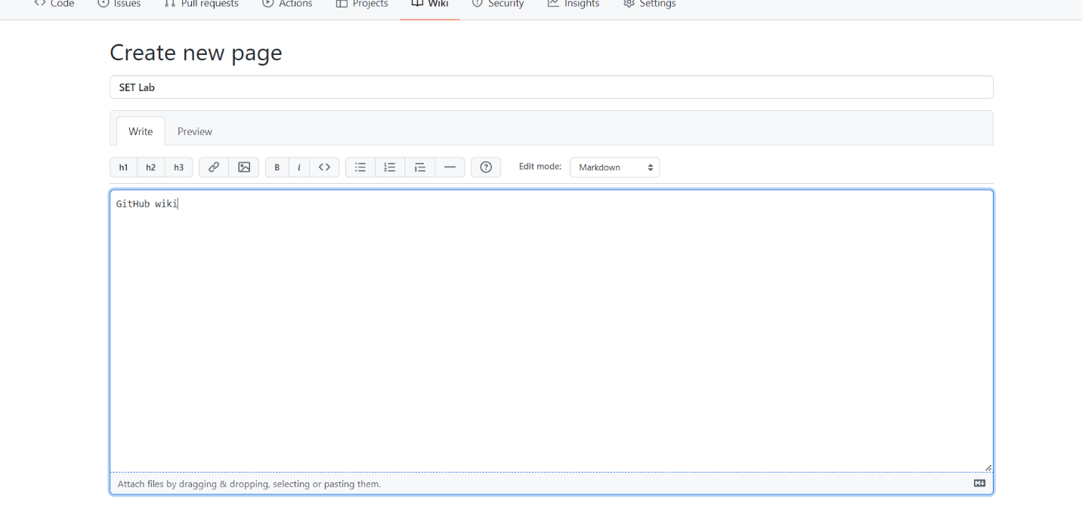

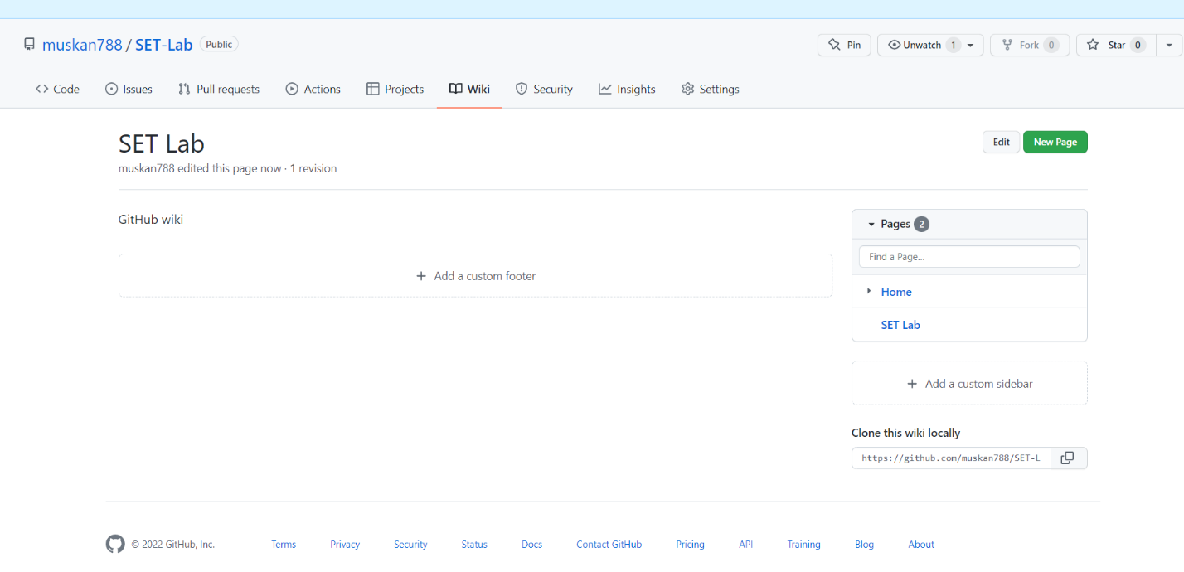

Q 2. In the GitHub repository given below there is a wiki page named assignment submission, update that wiki page with your PRN number.

<https://github.com/sdpwce/SETAssignment>

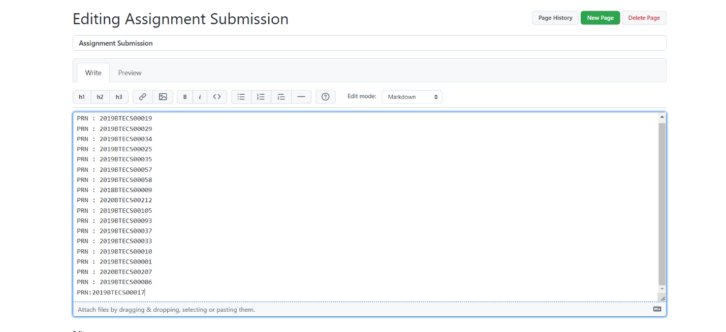

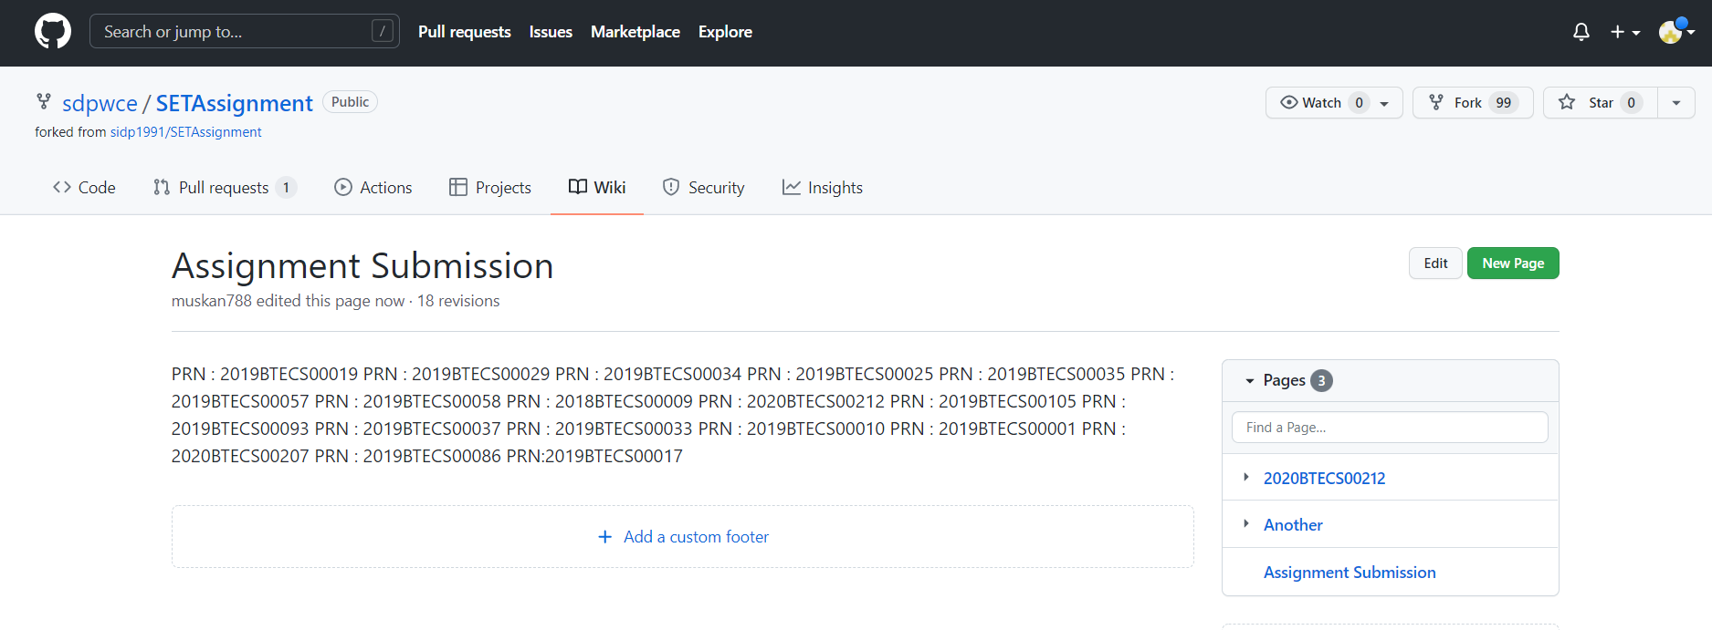

Q 3. In your respective GitHub repository go to the ‘SET Lab’ wiki page and create a footer and add custom sidebar.

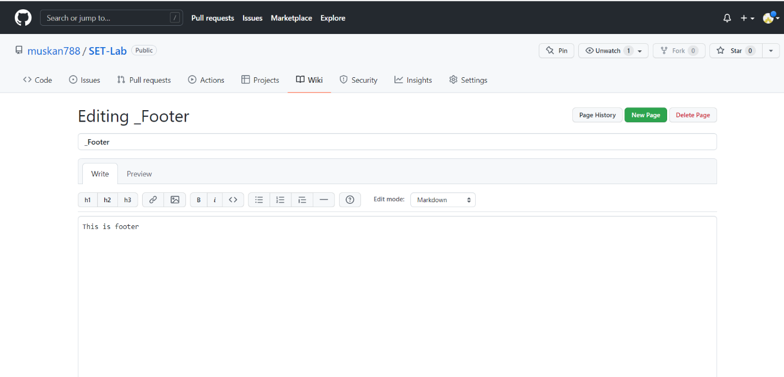

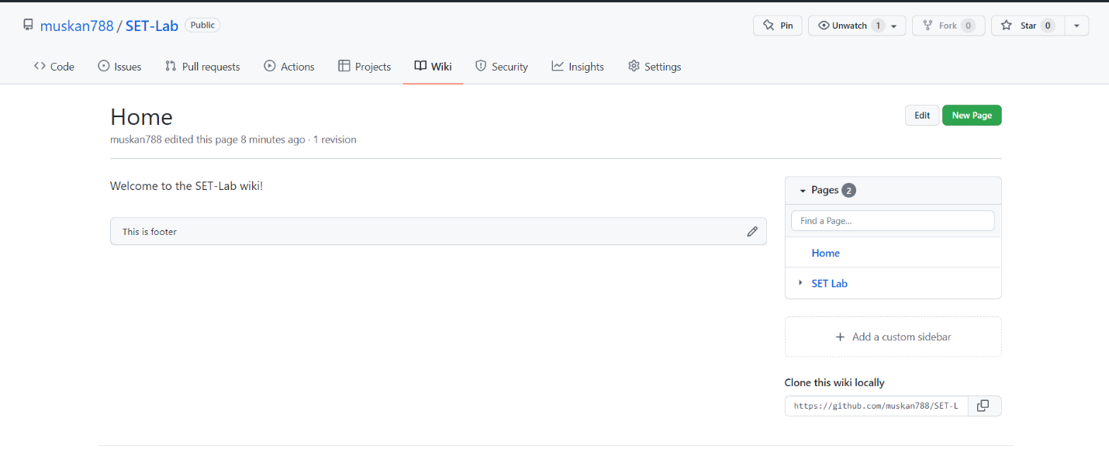

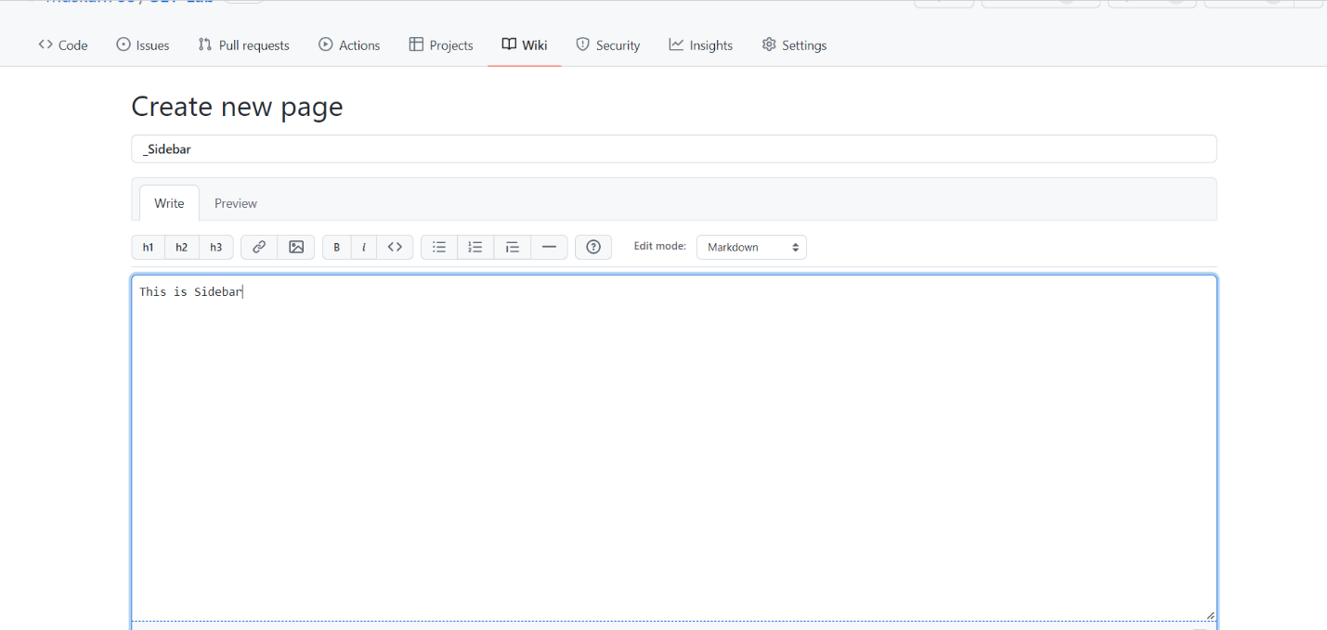

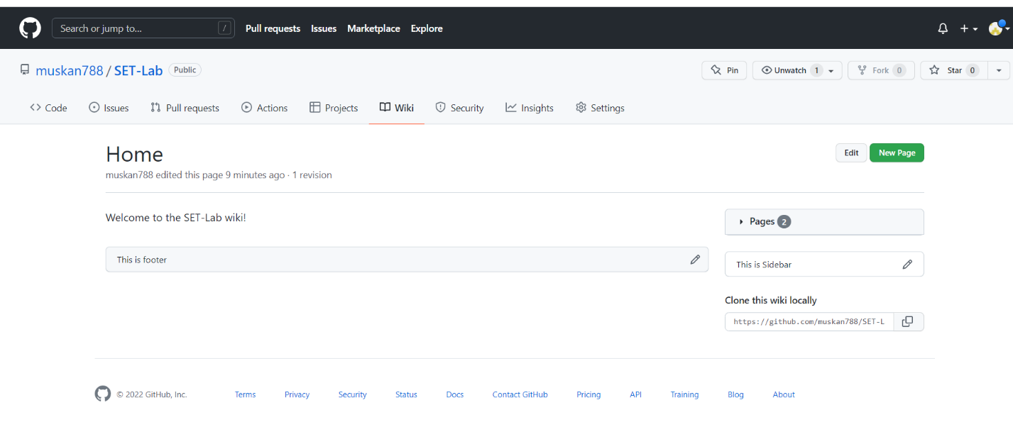

Q 4. Provide the features and brief information of below documentation tools

1. Read the Docs

* Read the Docs simplifies software documentation by automating building, versioning, and hosting of your docs for you.

Free docs hosting for open source

* We will host your documentation for free, forever. There are no tricks. We help over 100,000 open source projects share their docs, including a custom domain and theme.

Always up to date

* Whenever you push code to your favorite version control service, whether that is GitHub, BitBucket, or GitLab, we will automatically build your docs so your code and documentation are never out of sync.

Downloadable formats

* We build and host your docs for the web, but they are also viewable as PDFs, as single page HTML, and for eReaders. No additional configuration is required.

Multiple versions

* We can host and build multiple versions of your docs so having a 1.0 version of your docs and a 2.0 version of your docs is as easy as having a separate branch or tag in your version control system.

Read the Docs has grown substantially since its beginning as a weekend project and is closing in on being a top-1000 site on the internet. Today, we:

* Serve over 55 million pages of documentation a month
* Serve over 40 TB of documentation a month
* Host over 80,000 open source projects and support over 100,000 users
* Are supported by a very small team of dedicated engineers

1. Haroopad

Haroopad is a markdown enabled document processor for creating web-friendly documents.

You can author professional-looking documents of various formats: blog posts, slides, presentations, reports, email and more.

Haroopad gives you the same editing experience regardless of the platform you are working on. It runs on all three major operating systems—Windows, Mac OS X, and Linux.

[](https://camo.githubusercontent.com/51a71dd691be1cc9a45709d5bf53cdfd2f469ed4eb050a629c7eb67949848057/687474703a2f2f7061642e6861726f6f70726573732e636f6d2f6173736574732f696d616765732f6c6f676f2d736d616c6c2e706e67)

**New Features (v0.13.2)**

* New Features
  + Presentation Mode - [reference](http://pad.haroopress.com/page.html?f=how-to-write-presentation)
  + Drawing Diagram (flowchart, Sequence Diagram) - [reference](http://pad.haroopress.com/page.html?f=how-to-draw-diagram)
* New Syntax
  + Tasklist(GFM) - [reference](http://pad.haroopress.com/page.html?f=how-to-manage-tasklist)
* Added new code language & themes - [reference](http://pad.haroopress.com/page.html?f=how-to-write-fenced-code-block)
  + total 112 languages(swift, gradle ...) and 49 themes

**More changelog**

* Bugs
  + Fixed No confirm save in Windows on close Window with [X]
  + Fixed The file path can't contain space in Windows
* Enhancements
  + Update Codemirror Editor v4.8
  + Support Font in Math
  + Support \left and \right in Math
  + Support custom gfm code block delimiters
  + Enhance GFM tabls's column width issue
  + Enhance Two subsequent tables are rendered with no space
  + Enhance Equation rendering issues

**Main Features**

* Support cross platform
  + Window
  + Mac OS X
  + Linux 32/64
* Theme for editing
  + Themes for editor 30 styles
  + Syntax highlighting in fenced code block on editor
  + Ruby, Python, PHP, Javascript, C, HTML, CSS
  + based on CodeMirror
* Live Preview themes
  + 7 themes based [markdown-css](https://github.com/rhiokim/markdown-css)
* Syntax Highlighting
  + 71 languages & 44 styles based on highlight.js
* Custom Theme
  + Style based on CSS(Cascading Style Sheet)
* Font Size
  + Editor and Viewer font size control using Preference Window & Shortcuts
* Embedding Rich Media Contents - v0.8
  + Video, Audio, 3D, Text, Open Graph and oEmbed
  + About 100 Major Internet Services(Youtube, SoundCloud, Flickr...) Support
  + Drag & Drop support
* Display Mode - v0.8
  + Default(Editor:Viewer), Reverse(Viewer:Editor), Only Editor, Only Viewer (View > Mode)
* Insert Current Date & Time - v0.8
  + Various Format support (Insert > Date & Time)
* HTML to Markdown - v0.8
  + Drag & Drop your selected text on Web Browser
* Options for markdown parsing
* CLI(Command Line Interface) - v0.12.1
  + $ haroopad -f [ /path/to/a.md ./path/to/b.md ]: files
  + $ haroopad --mode: only view or edit mode
    - $ haroopad --mode view: view mode
    - $ haroopad --mode edit: edit mode
* Outline View
* Vim Key-binding
* Export to PDF, HTML
* Styled HTML copy to clipboard for WYSIWYG editors
* Auto Save & Restore
* Document state information
* Tab or Spaces for Indentation
* Colum(Single, Two and Three) Layout View
* Markdown Syntax Help Dialog
* Markdown Folding
* Import and Export settings

**Internationalization**

* English
* Korea (한국어)
* Spanish (Español) - [davegomez](https://github.com/davegomez)
* Chinese Simplified (中文) - [toiletfreak](https://github.com/toiletfreak)
* German (Deutsch) - [Tobias Mücksch](https://github.com/tobiasmuecksch)
* Vietnamese (Tiếng Việt) - [nguyenkinh](https://github.com/nguyenkinh)
* Russian (Русский) - [aprilix](https://github.com/aprilix)
* Greek (Ελληνικά) - [pdudis](https://github.com/pdudis)
* Portuguese (Portuguesa) - [alexandre mbm](https://github.com/alexandre-mbm)
* Japanese (日本語) - [Toshiyuki Tega](https://github.com/Toshiyuki-Tega)
* Italy (Italiano) - [Daniele Pitrolo](https://github.com/Zeriuno)
* Indonesia (Bahasa Indonesia) - [Reza Faiz A. Rahman](https://github.com/rezafaizarahman)
* Turkey (Türkçe) - [Eray AYDIN](https://github.com/erayaydin)
* French (Français) - [MarcBoyer](https://github.com/MarcBoyer), [Daniel Ménard](https://github.com/daniel-menard)

**Enhanced Markdown Syntax**

* Added [TOC] Syntax
  + Now you can easily embed table of content in documents.
  + Left Align: [TOC "float:left"]
  + Right Align: [TOC "float:right"]
* ![]() Extended image syntax
  + ![alt text](url "title" "css")
* [Gitub Flavored Markdown](http://github.github.com/github-flavored-markdown/) & extensions
  + Syntax highlighting
  + Table
  + URL autolinking
  + Strikethrough
  + Smartypants
* Mathematics Expression
  + Inline Expression: $$$...$$$
  + Block Expression: $$...$$
  + Added Option inline mathematics expression (**$**, $$$)
* Added Superscript, Subscript
  + Sup^superscript^, Sub~subscript~
* Extended Image Syntax
  + If ![](path/*.mp3) then <audio> / extensions mp3, ogg
  + If ![](path/*.mp4) then <video> / extensions mp4, ogv, webm
* Footnote
  + Footnote: [^identity]
  + Footnote Reference: [^identity]: text
* Tasklist
  + Task: - [ ]
  + Task (Done): - [x]

**TODO**

* Plugin System
* Integrating with cloud environments

**And more?**

* Official site : [http://pad.haroopress.com](http://pad.haroopress.com/)
* Blog & Manual : <http://pad.haroopress.com/page.html>
* User echo : [http://haroopad.userecho.com](http://haroopad.userecho.com/)

Q 5. With help of above tools specified in Q 5 create different project based and product based documents and show its corresponding features as given below (perform the task for every feature)

* Project based document will contain Project timelines, Internal meeting notes, reports and Product requirements.
* Product based document will contain clear understanding of how the product works on the front-end

Note- You can create these technical documentations for your previous mini projects.

**Read the docs Features**

* Docs viewable as web pages, PDFs, HTML, and eReader files
* Branching and versioning ensures no overlap when updating docs
* Free hosting with a custom domain.

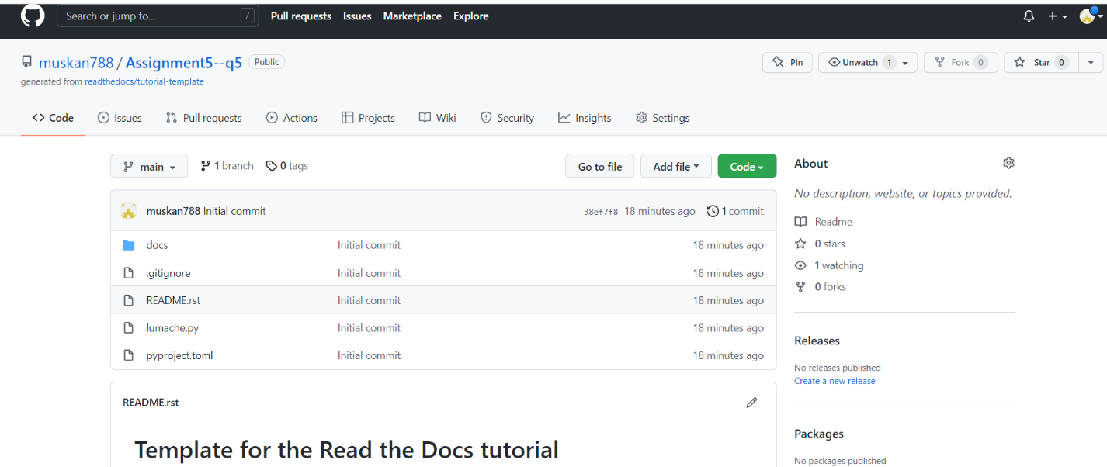

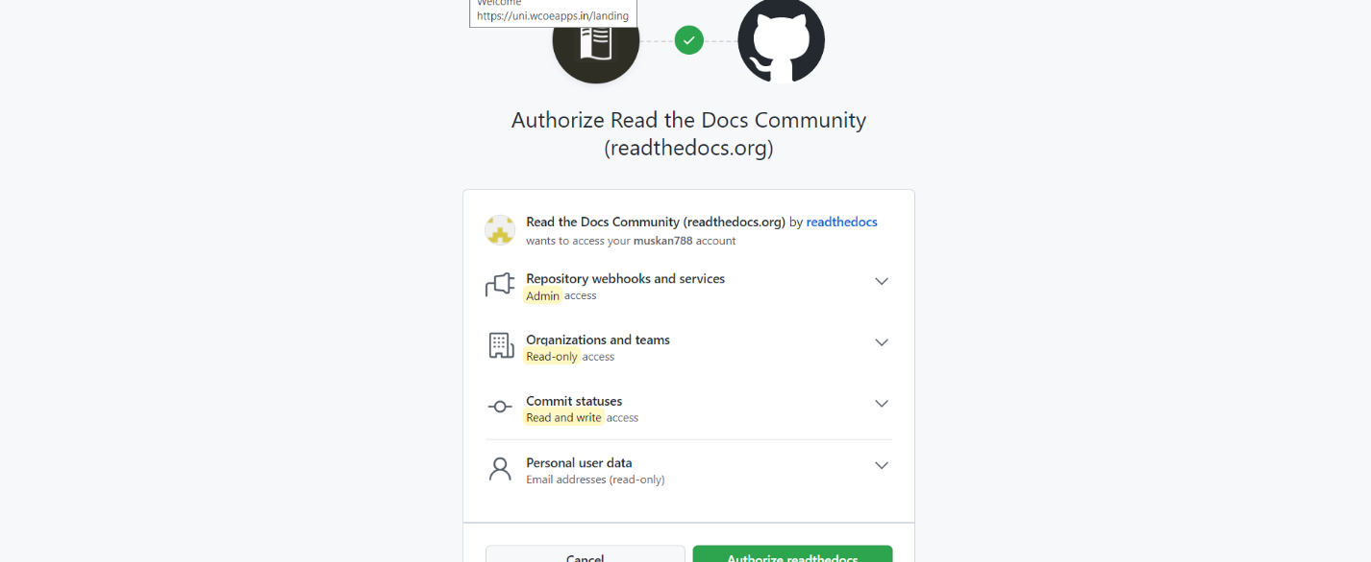

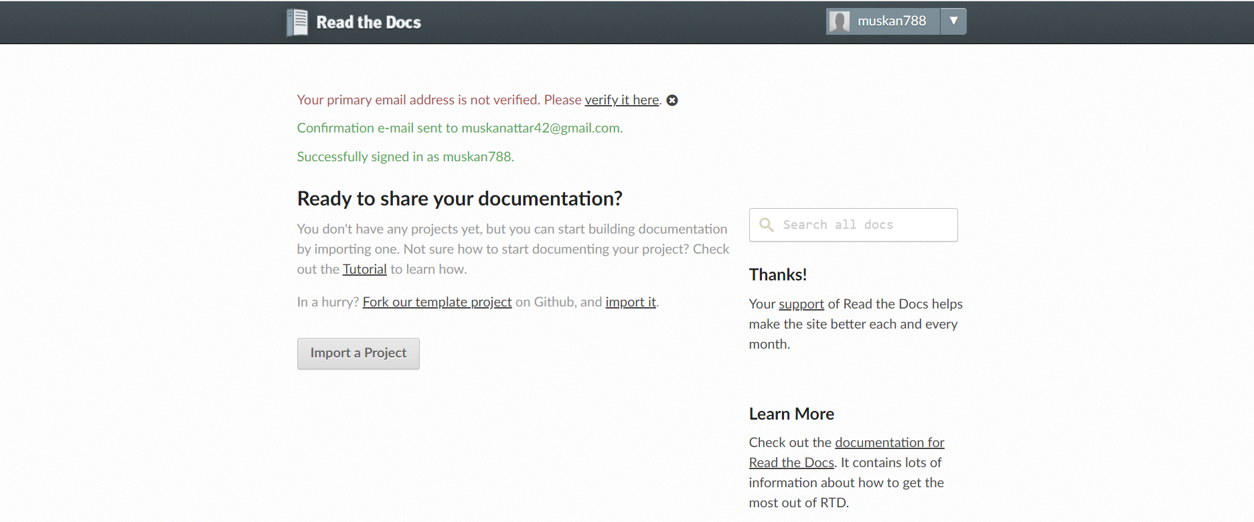

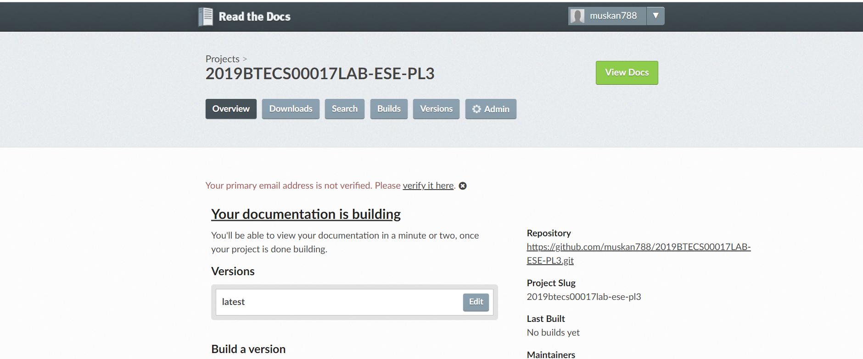

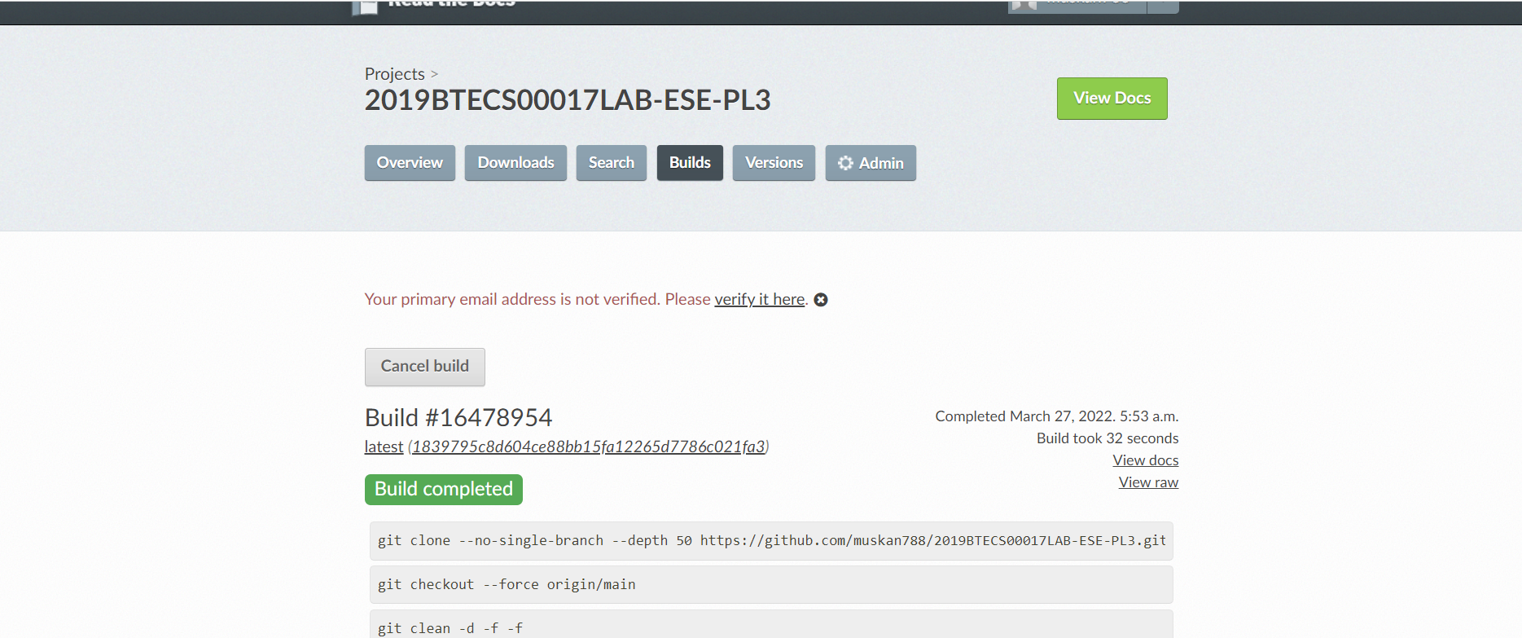

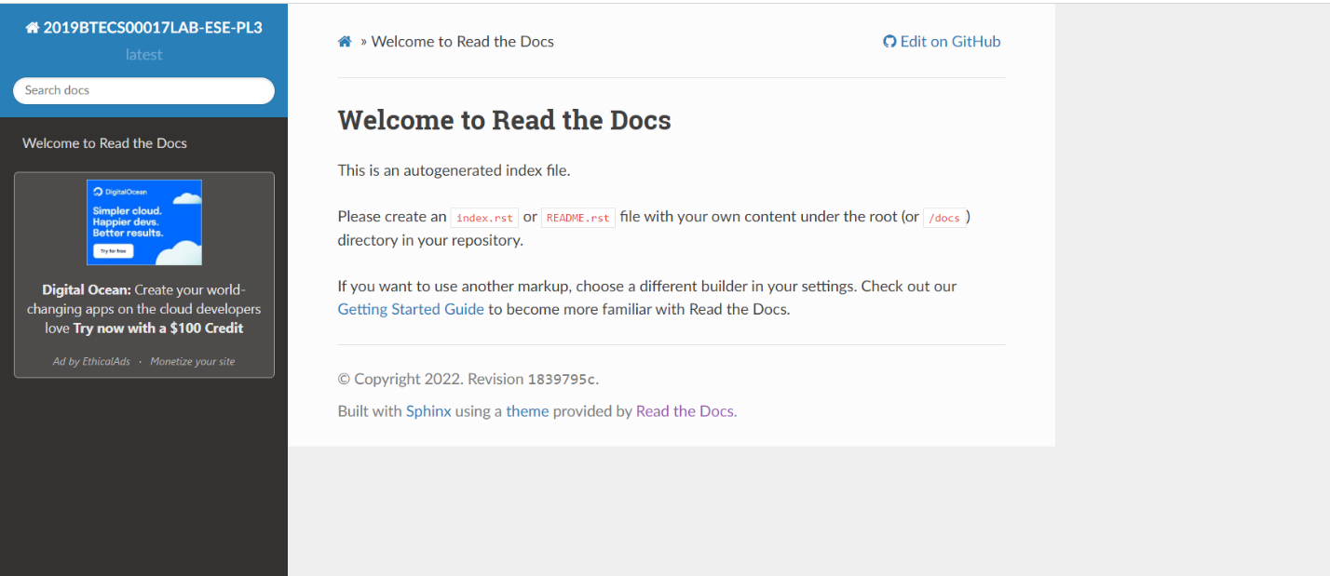

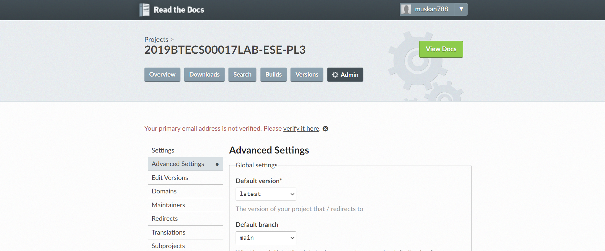

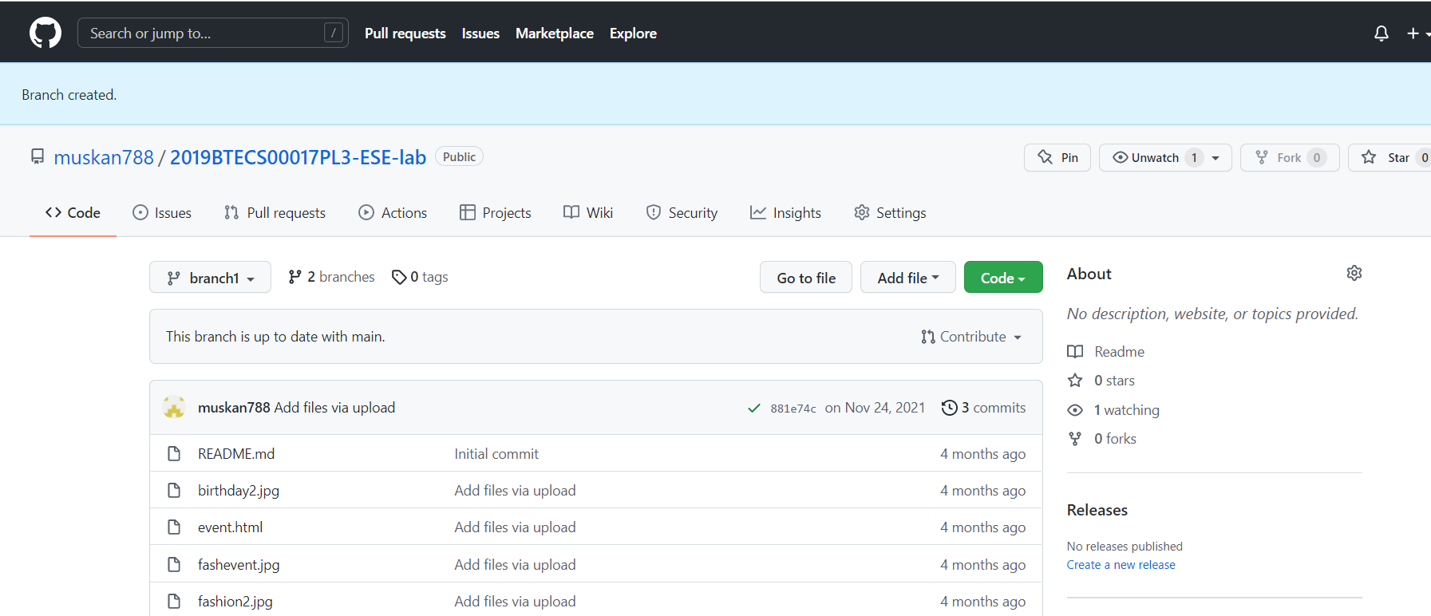

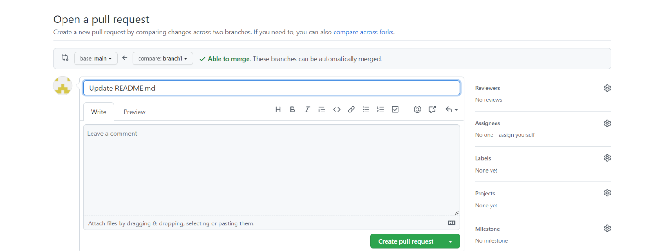

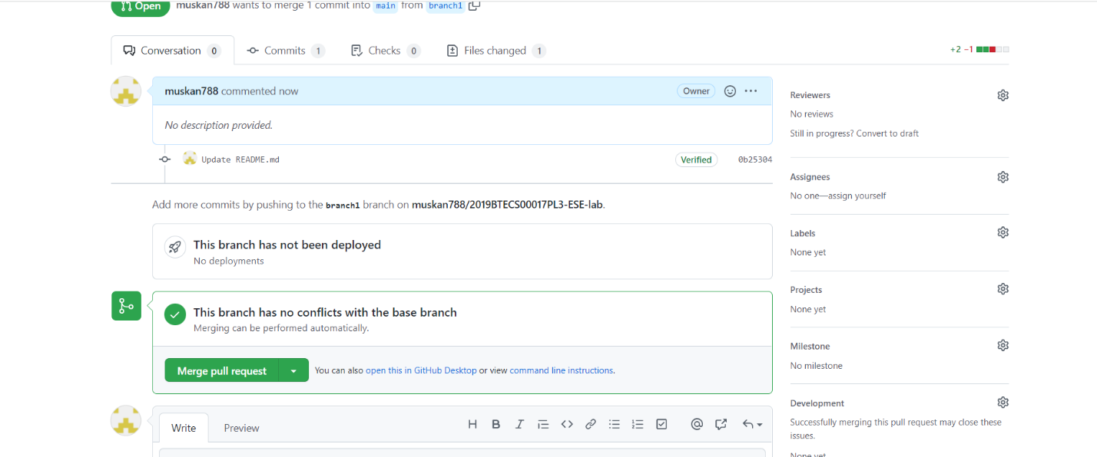

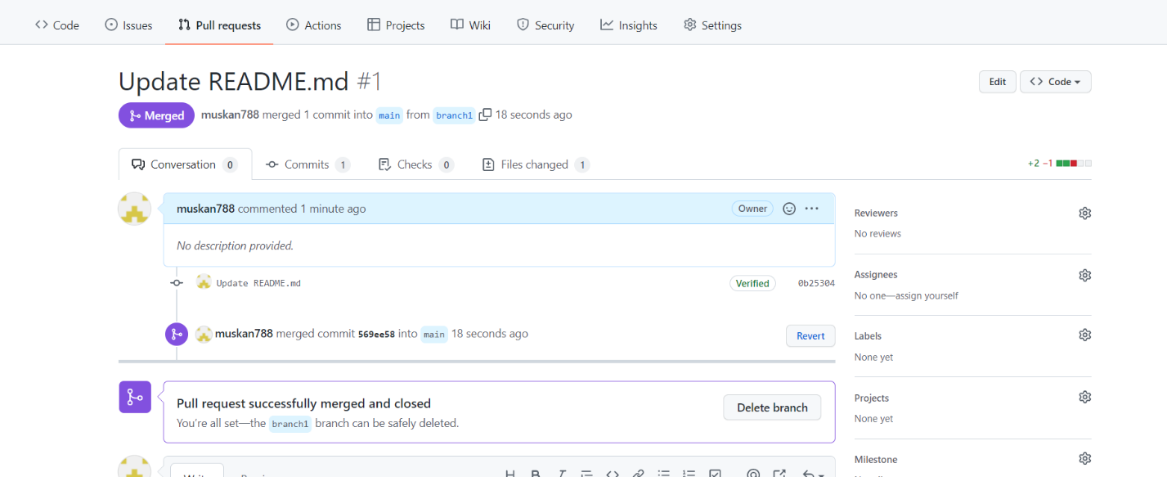

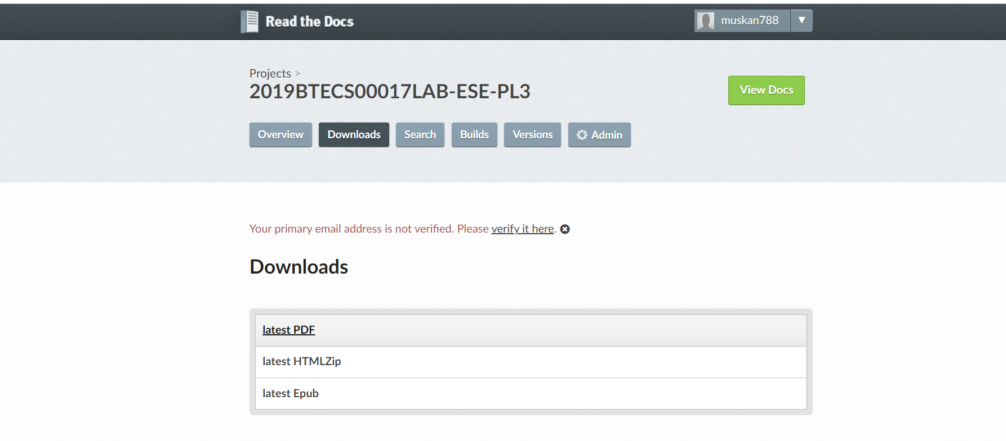

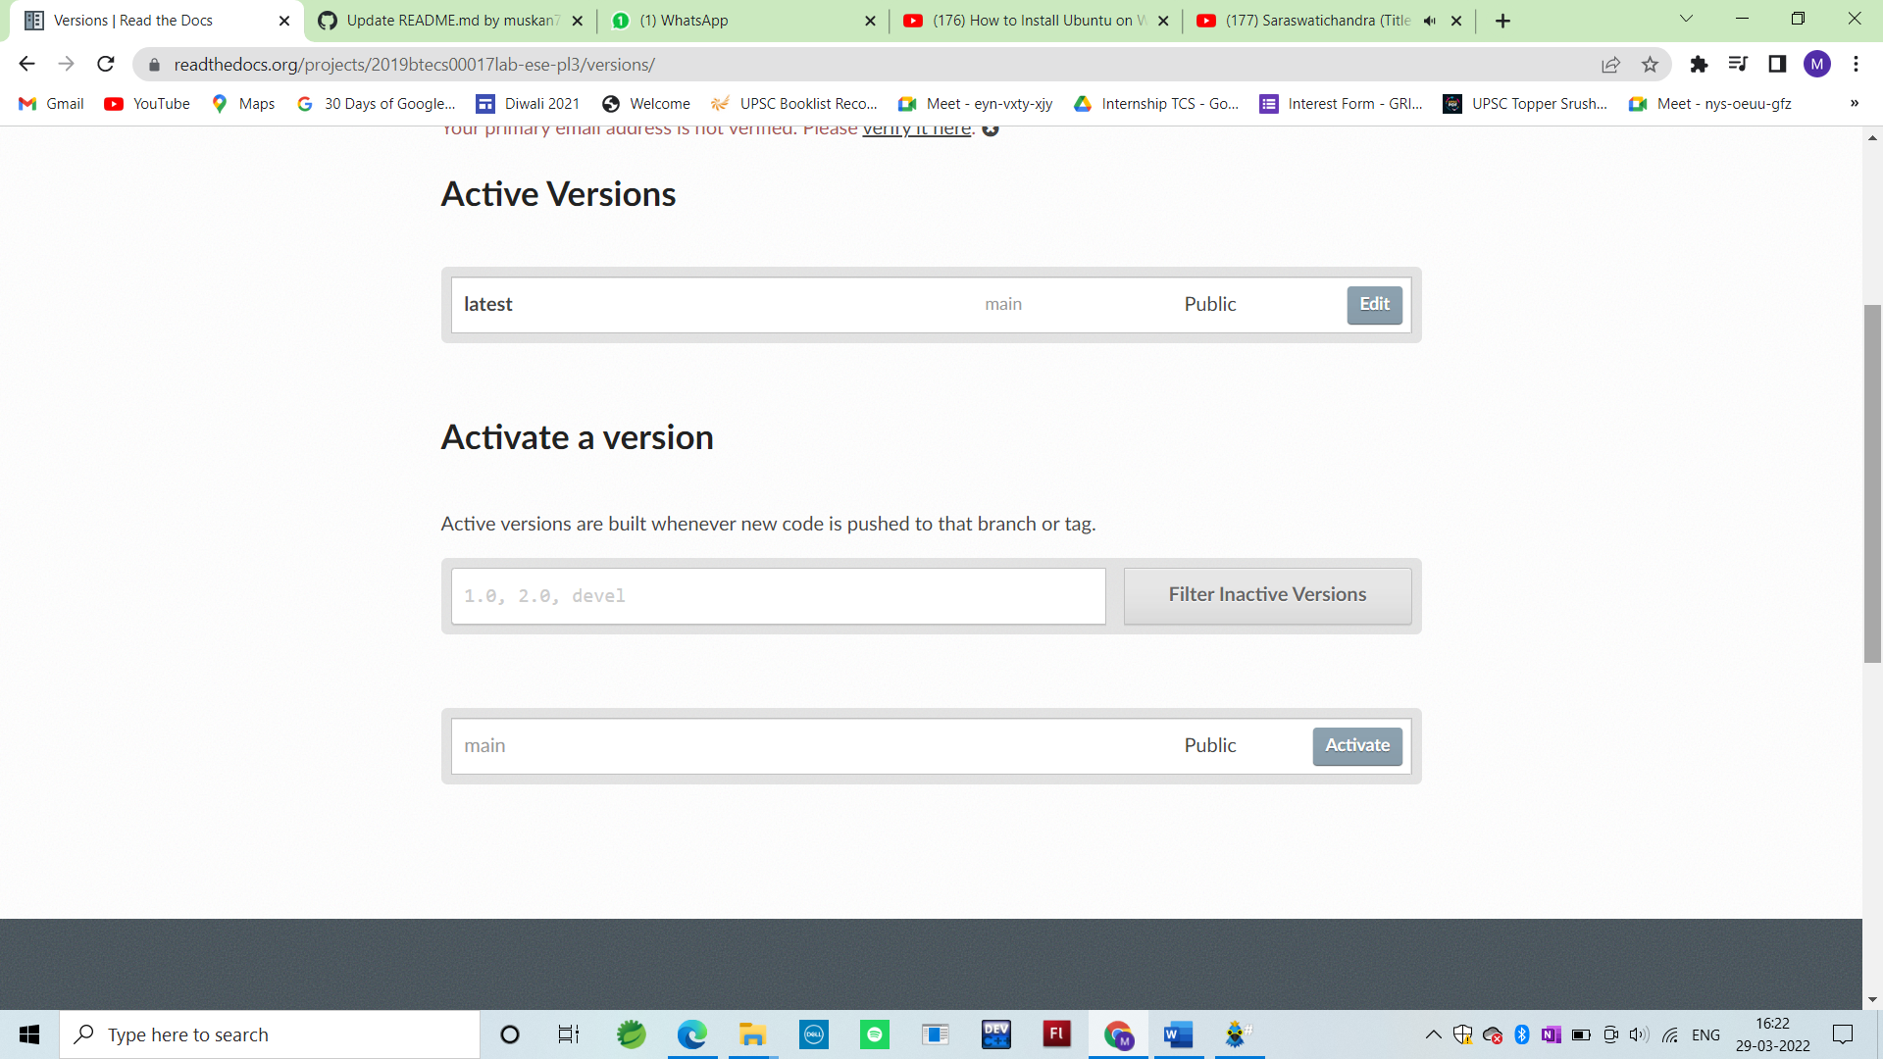

**Haroopad Features**

* Themes, skins, and customizable UI components
* Import files from YouTube, Twitter, Vimeo, Slideshare, Flickr, Instagram, and more
* Export documents to Workpress, convert to PDF/HTML

